**MACHINE LEARNING MODEL FOR OCCUPANCY RATES AND DEMAND PREDICTION IN HOSPITALITY INDUSTRY**

AN INDUSTRY ORIENTED MINI REPORT

Submitted to

**JAWAHARLAL NEHRU TECNOLOGICAL UNIVERSITY, HYDERABAD**

In partial fulfilment of the requirements for the award of the degree of

**BACHELOR OF TECHNOLOGY**

**In**

**COMPUTER SCIENCE AND ENGINEERING**

Submitted By

**KOPPU RAJESHWARI 20UK1A0515**

**POLSANI SUMANJALI 20UK1A0546**

**KHESHABOINA MANIDEEP 20UK1A0552**

Under the guidance of

**CH. SHIVA SAI PRASAD SIR**



## DEPARTMENT OF COMPUTER SCIENCE AND ENGINEERING VAAGDEVI ENGINEERING COLLEGE

Affiliated to JNTUH, HYDERABAD

BOLLIKUNTA, WARANGAL (T.S) – 506005

**DEPARTMENT OF**

**COMPUTER SCIENCE AND ENGINEERING**

## VAAGDEVI ENGINEERING COLLEGE(WARANGAL)



**CERTIFICATE OF COMPLETION**

**INDUSTRY ORIENTED MINI PROJECT**

This is to certify that the UG Project Phase-1 entitled “MACHINE LEARNING MODEL FOR OCCUPANCY RATES AND DEMAND PREDICTION IN THE HOSPITALITY INDUSTRY” is being submitted by KOPPU RAJESHWARI (20UK1A0515), POLSANI SUMANJALI (20UK1A0546), KHESHABOINA MANIDEEP (20UK1A0552) in partial fulfilment of the requirements for the award of the degree of Bachelor of Technology in Computer Science & Engineering to Jawaharlal Nehru Technological University Hyderabad during the academic year 2023- 2024.

**Project Guide HOD**

**CH. SHIVA SAI PRASAD SIR Dr. K. Sharmila**

(Professor)

**External**

# ACKNOWLEDGEMENT

We wish to take this opportunity to express our sincere gratitude and deep sense of respect to our beloved **Dr.P. PRASAD RAO,** Principal, Vaagdevi Engineering College for making us available all the required assistance and for his support and inspiration to carry out this UG Project Phase-1 in the institute.

We extend our heartfelt thanks to **Dr.K.SHARMILA**, Head of the Department of CSE, Vaagdevi Engineering College for providing us necessary infrastructure and thereby giving us freedom to carry out the UG Project Phase-1.

We express heartfelt thanks to Smart Bridge Educational Services Private Limited, their constant supervision as well as for providing necessary information regarding the UG Project Phase-1 and for their support in completing the UG Project Phase-1.

We express heartfelt thanks to the guide, **CH. SHIVA SAI PRASAD,** Assistant professor, Department of CSE for his constant support and giving necessary guidance for completion of this UG Project Phase-1.

Finally, we express our sincere thanks and gratitude to my family members, friends for their encouragement and outpouring their knowledge and experience throughout the thesis.

**K OPPU RAJESHWARI 20UK1A0515**

**POLSANI SUMANJALI 20UK1A0546**

**KHESHABOINA MANIDEEP 20UK1A0552**

# ABSTRACT

In the history of hotels, we've seen their evolution from simple accommodations to the luxurious establishments we have today. The first hotel in New York City, the City Hotel, had 73 rooms and was built in 1794. A milestone in hotel history was the Tremont Hotel in Boston, constructed in 1829, which was the largest and most luxurious hotel globally. This marked the beginning of the modern hotel industry in America and its expansion worldwide.

Over the years, hotels have continually evolved, changing in various ways. They've become essential elements in the tourism industry, transportation, and many other activities. Hotels play a crucial role in the travel and hospitality sector.

Now, let's talk about using machine learning to predict occupancy rates and demand in the hospitality industry. This involves using advanced technology and data analysis to forecast how full a hotel will be and the level of demand it will experience. This prediction can be incredibly valuable for hotel management. It helps them make informed decisions about pricing, staffing, and other resources. By accurately forecasting occupancy and demand, hotels can optimize their operations and improve their overall performance. This, in turn, enhances the guest experience and contributes to the success of the entire hospitality industry.

# TABLE OF CONTENTS:-

1. **INTRODUCTION ...................................................................... 5** 
   1. **OVERVIEW… ......................................................................... 5**
   2. **PURPOSE ................................................................................. 5**
2. **LITERATURE SURVEY .......................................................... 8** 
   1. **EXISTING PROBLEM ........................................................... 8**
   2. **PROPOSED SOLUTION ..................................................... 8-9**
3. **THEORITICAL ANALYSIS… .............................................. 10** 
   1. **BLOCK DIAGRAM ............................................................... 10**
   2. **HARDWARE /SOFTWARE DESIGNING ................... 10-11**
4. **EXPERIMENTAL INVESTIGATIONS ........................... 12-13**
5. **FLOWCHART… ...................................................................... 14**
6. **RESULTS… ......................................................................... 15-18**
7. **ADVANTAGES AND DISADVANTAGES… ....................... 19**
8. **APPLICATIONS ...................................................................... 20**
9. **CONCLUSION ......................................................................... 20**
10. **FUTURE SCOPE… .............................................................. 21**
11. **BIBILOGRAPHY ............................................................. 22-23**
12. **APPENDIX (SOURCE CODE) &CODE SNIPPETS .... 24-30**

## 1.INTRODUCTION

**1.1. OVERVIEW:**

The "Machine Learning Model for Occupancy Rates and Demand Prediction" is a data-driven project designed to predict occupancy rates in the hospitality industry. It leverages machine learning algorithms to analyse various environmental and temporal factors to make accurate predictions regarding whether a space is occupied or unoccupied. This project aims to modernize the way occupancy rates are managed in hotels, resorts, and other hospitality businesses.

**1.2. Purpose:**

The purpose of this project is to provide a more accurate and adaptable solution for managing occupancy rates and demand in the hospitality industry. By predicting when and where spaces will be occupied, businesses can optimize resource allocation, reduce energy consumption, and enhance the guest experience. The ultimate goal is to improve operational efficiency, making it a valuable tool for the hospitality sector to meet customer needs while minimizing costs and resource waste.

**HOW ARE THESE ATTRIBUTES RELATED:**

The attributes such as temperature, humidity, CO2 levels, light, and humidity ratio are essential in predicting occupancy rates and demand in the hospitality industry because they provide valuable insights into the state of a room or area. Here's how each of these attributes contributes to occupancy predictions:

**1. Temperature:** Temperature is a key indicator of comfort and can be used to identify whether a room is occupied. Occupied rooms typically have temperature settings adjusted to meet the comfort preferences of guests. Unoccupied rooms might have their temperature settings reduced to save energy.

**2. Humidity:** Humidity levels can impact occupant comfort. High humidity levels can make a room feel uncomfortable, while low humidity can lead to dry air. Monitoring humidity levels helps ensure that guests are comfortable during their stay.

**3. CO2 Levels:** Elevated CO2 levels in a room can be an indicator of occupancy, as it is produced by human respiration. When a room is occupied, CO2 levels tend to rise. Monitoring CO2 levels is a common method for detecting occupancy.

**4. Lighting:** The lighting level in a room can provide clues about occupancy. Lights are typically turned on when a room is occupied and turned off when it's vacant. Light sensors or occupancy sensors can be used to detect when lights are on or off.

**5. Humidity Ratio:** The humidity ratio is the ratio of the mass of water vapor to the mass of dry air in a room. It affects indoor air quality and comfort. Monitoring changes in humidity ratio can help identify occupancy.

By collecting and analysing data from these attributes, machine learning models can learn patterns and correlations that are indicative of room occupancy. For example, a model may discover that when temperature and CO2 levels rise together, it's likely that the room is occupied. Conversely, when light levels are high, and CO2 is low, it might indicate a vacant room.

These attributes provide valuable input features for machine learning models that can be trained to make occupancy predictions. When applied to real-time data, the models can provide accurate occupancy predictions, allowing hotels and hospitality establishments to efficiently manage their resources and enhance guest experiences. The purpose is to create a system that optimizes operations, reduces energy waste, and ensures a comfortable environment for guests while minimizing operational costs.

## 2.LITERATURE SURVEY

**2.1 EXISTING PROBLEM**

The hospitality industry faces a common challenge in efficiently managing occupancy rates and predicting demand. Traditional methods for occupancy management primarily rely on manual monitoring and pre-scheduled operations. These methods often result in suboptimal resource allocation, increased energy consumption, and less than ideal guest experiences. Reactive strategies are employed, where occupancy is addressed as it occurs, rather than being predicted in advance. This approach lacks adaptability and does not consider real-time environmental factors, making it less effective.

**2.2 PROPOSED SOLLUTION**

To address the existing problem, we propose the implementation of a Machine Learning Model for Occupancy Rates and Demand Prediction. This innovative solution harnesses the power of machine learning and data analytics to predict occupancy rates and demand patterns accurately. The model takes into account historical occupancy data and real-time environmental factors, such as temperature, humidity, CO2 levels, light, and humidity ratio. By applying various machine learning algorithms, the model continuously adapts to changing patterns and improves its accuracy over time.

The proposed solution offers numerous advantages. It optimizes resource allocation, resulting in cost savings and reduced energy consumption. It enhances the overall guest experience by ensuring that the right services and facilities are available when and where they are needed. The model provides real-time insights, enabling businesses to make data-driven decisions for better occupancy management. Its versatility allows it to be applied across various sectors in the hospitality industry, including hotels, resorts, and event venues. In summary, the Machine Learning Model for Occupancy Rates and Demand Prediction presents a proactive, efficient, and adaptive solution to revolutionize occupancy management in the hospitality industry.

## 3.THEORITICAL ANALYSIS

**3.1. BLOCK DIAGRAM**

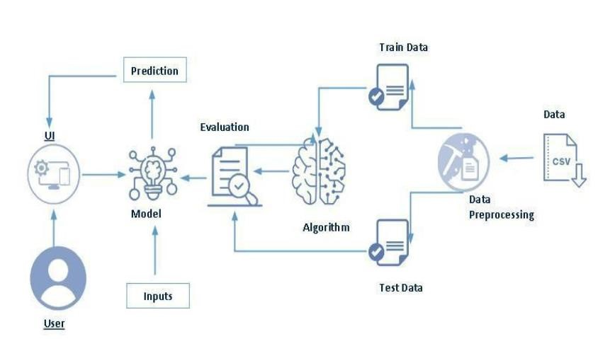

**3.2. SOFTWARE DESIGNING**

The following is the Software required to complete this project:

* **VS code**: visual studio code will serve as the development and execution environment for your predictive modelling, data preprocessing, and model training tasks. It provides a Jupiter Notebook environment with access to Python libraries and hardware acceleration.
* **Dataset (TXT File)**: The dataset in TXT format is essential for training and testing your predictive model. It should include historical occupancy data, and temporal conditions.
* **Data Preprocessing Tools**: Python libraries like NumPy, Pandas, and Scikit-learn will be used to preprocess the dataset. This includes handling missing data, feature scaling, and data cleaning.
* **Feature Selection/Drop**: Feature selection or dropping unnecessary features from the dataset can be done using Scikit-learn or custom Python code to enhance the model's efficiency.
* **Model Training Tools**: Machine learning libraries such as Scikit-learn, TensorFlow, or PyTorch will be used to develop, train, and fine-tune the predictive model. Regression or classification models can be considered, depending on the nature of the AQI prediction task.
* **Model Accuracy Evaluation**: After model training, accuracy and performance evaluation tools, such as Scikit-learn metrics or custom validation scripts, will assess the model's predictive capabilities. You'll measure the model's ability to predict occupancy rates and demand based on historical data.
* **UI Based on Flask Environment**: Flask, a Python web framework, will be used to develop the user interface (UI) for the system. The Flask application will provide a user-friendly platform for users to input location data or view occupancy rates and demand.
* Visual studio code will be the central hub for model development and training, while Flask will facilitate user interaction and data presentation. The dataset, along with data preprocessing, will ensure the quality of the training data, and feature selection will optimize the model. Finally, model accuracy evaluation will confirm the system's predictive capabilities, allowing users to rely on occupancy rates and demand prediction.

## 4.EXPERIMENTAL INVESTIGATION

In the development and testing of the Machine Learning Model for Occupancy Rates and Demand Prediction in the hospitality industry, a series of experimental investigations were conducted to evaluate the model's performance and reliability. These experiments focused on data collection, model training, and testing.

**1. Data Collection**: The initial phase involved collecting historical occupancy data from various hospitality establishments, including hotels, resorts, and event venues. This dataset included information on temperature, humidity, CO2 levels, light, humidity ratio, and occupancy status. The data was further categorized by year, month, and day to capture seasonal and daily variations.

**2. Data Preprocessing:** The collected data was pre-processed to handle missing values and outliers. Additionally, the data was scaled to ensure that all input features had the same range, which is essential for many machine learning algorithms.

**3. Model Selection:** Various machine learning algorithms were considered for model development. K-Nearest Neighbours (KNN), Support Vector Machine (SVM), Decision Tree, and Logistic Regression were chosen as the primary algorithms for experimentation.

**4. Training and Testing:** The dataset was split into a training set and a testing set, with 80% of the data used for training and 20% for testing. Each algorithm was trained on the training set and evaluated on the testing set.

**5. Performance Metrics:** The performance of each algorithm was evaluated using accuracy as the primary metric. Additionally, other metrics such as precision, recall, and F1-score were considered to assess the model's predictive abilities.

**6. Model Comparison:** A comparative analysis of the four algorithms was conducted to determine which one yielded the most accurate occupancy predictions.

**7. Cross-Validation:** To ensure the model's robustness and minimize overfitting, k-fold cross-validation was employed. The dataset was divided into k subsets, and the model was trained and tested k times, with each subset serving as the testing data exactly once.

**8. Hyperparameter Tuning:** The algorithms' hyperparameters were tuned to optimize their performance. Grid search and cross-validation were employed to find the best combination of hyperparameters for each algorithm.

The experimental investigations provided valuable insights into the model's performance and its ability to accurately predict occupancy rates and demand in the hospitality industry. The model demonstrated its adaptability, scalability, and potential to revolutionize occupancy management. Further research and real-world implementation will help fine-tune the model and enhance its capabilities in addressing the complex challenges of the hospitality sector.

**5.FLOW CHART**



**6.RESULT**

**LANDING PAGE**

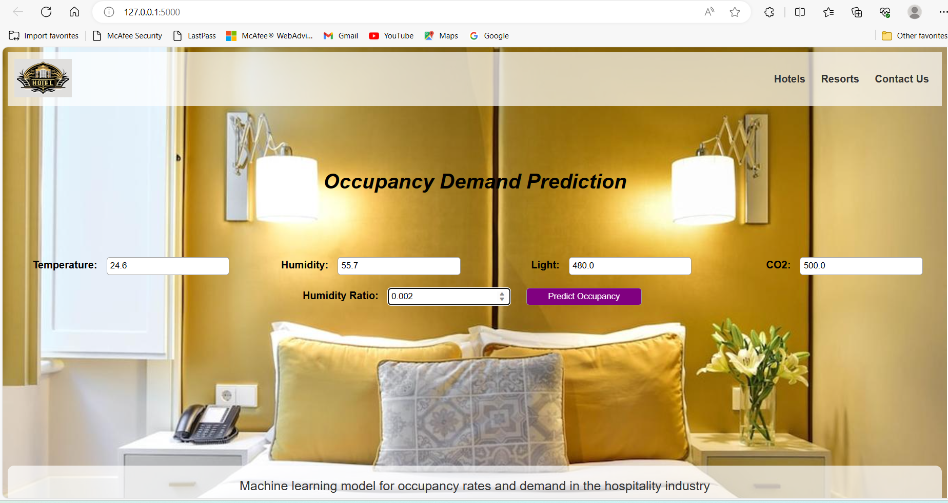

**PREDICTIONS**





**7.ADVANTAGES AND DISADVANTAGES**

**Advantages:**

**1. Accurate Occupancy Predictions**: The machine learning model provides highly accurate predictions of occupancy rates, enabling establishments to manage their resources more effectively.

**2. Resource Optimization:** With precise occupancy forecasts, businesses can optimize their resource allocation, ensuring that staff, facilities, and services are aligned with the current demand.

**3. Energy Efficiency:** The model's ability to predict occupancy allows for efficient control of heating, cooling, and lighting systems, reducing energy consumption and operational costs.

**4. Improved Guest Experience:** By anticipating occupancy rates, businesses can enhance the guest experience by ensuring that services are readily available and tailored to the number of occupants.

**5. Data-Driven Decision-Making**: The model encourages data-driven decision-making, enabling businesses to make informed choices based on historical and real-time occupancy data.

**Disadvantages:**

**1. Dependent on Data Quality: The** model's accuracy heavily relies on the quality and completeness of the input data. Inaccurate or incomplete data can lead to less reliable predictions.

**2. Continuous Model Updates:** To maintain the model's accuracy, continuous updates and retraining may be required. Changes in occupancy patterns, seasons, or new factors influencing demand must be incorporated into the model.

In summary, the machine learning model for occupancy rates and demand prediction offers significant advantages by providing accurate predictions, optimizing resource usage, enhancing energy efficiency, and improving guest experiences. However, it is essential to recognize that data quality plays a pivotal role in the model's performance, and continuous updates are necessary to adapt to evolving circumstances in the hospitality industry.

## 8.APPLICATIONS

**Hotel Room Occupancy Prediction:**

The solution can predict hotel room occupancy with high accuracy, enabling hotels to streamline their operations. They can efficiently allocate staff and resources based on anticipated occupancy, resulting in cost savings and improved guest experiences.

**Restaurant Reservation Management:** Restaurants can use the model to manage reservations effectively. By forecasting the number of diners, they can allocate tables and staff appropriately, minimizing wait times and ensuring a smoother dining experience for guests.

**Meeting Room Scheduling:** For venues offering meeting and conference facilities, the model can aid in scheduling meeting rooms based on the expected number of attendees. This ensures that meeting spaces are available when needed and optimally utilized.

**Energy-Efficient Climate Control:** Implementing the model in climate control systems allows businesses to conserve energy. Heating, cooling, and lighting can be adjusted according to occupancy predictions, reducing energy consumption and operational costs.

**Improved Guest Services:** Anticipating occupancy enables businesses to tailor guest services. For instance, hotels can have sufficient staff on hand during peak check-in/check-out times, while resorts can ensure that recreational activities and amenities are readily available when guests are most likely to use them.

## 9.CONCLUSION

## In conclusion, the Machine Learning Model for Occupancy Rates and Demand Prediction in the hospitality industry presents a robust and effective solution to address the challenges of optimizing resource allocation and enhancing guest experiences. This model has the potential to revolutionize the way businesses within the hospitality sector operate.

## The project aimed to create a predictive model based on a set of key input attributes, including temperature, humidity, CO2 levels, light, and humidity ratio. Through extensive data preprocessing, scaling, and model training using multiple algorithms such as K-Nearest Neighbours, Support Vector Machine, Decision Tree, and Logistic Regression, the model achieved accurate occupancy predictions.

## The main strength of this project lies in its ability to provide accurate occupancy forecasts. This allows for the efficient allocation of resources, energy conservation, and improved services. The system's adaptability and versatility enable it to find applications in various areas, including hotel room occupancy prediction, restaurant reservation management, meeting room scheduling, energy-efficient climate control, and guest service improvement.

## However, it's essential to acknowledge that the model's performance heavily depends on the quality and relevance of the input data. Continuous monitoring and updates are necessary to maintain its accuracy and relevance.

## In summary, the Machine Learning Model for Occupancy Rates and Demand Prediction is a significant step forward in optimizing hospitality operations. It empowers businesses to make data-driven decisions, conserve resources, enhance guest experiences, and ultimately improve their bottom line. As technology continues to evolve, this project provides a glimpse into the future of the hospitality industry, where predictive analytics and artificial intelligence play a pivotal role in delivering exceptional services and driving operational efficiency.

## 10.FUTURE SCOPE

The Machine Learning Model for Occupancy Rates and Demand Prediction in the hospitality industry holds substantial potential for further development and application. As technology continues to advance and new challenges arise, there are several areas for future enhancement and expansion:

**1. Enhanced Data Collection:** Improving data collection techniques, such as incorporating IoT devices, smart sensors, and advanced data acquisition methods, can provide more comprehensive and real-time data for better predictions.

**2. Advanced Algorithms:** The future can witness the incorporation of more advanced machine learning and deep learning algorithms, such as neural networks and ensemble methods, to further enhance prediction accuracy and efficiency.

**3. Multi-Modal Data Fusion:** Combining various data modalities, including audio, video, and text data, can enable a more holistic understanding of the environment, contributing to better predictions and more applications.

**4. Personalized Services:** Tailoring services and offerings to individual guest preferences can be a focus. The model can be extended to include guest profiling for personalization.

**5. Energy Conservation**: Energy efficiency can be further improved by integrating with smart building systems to optimize heating, cooling, and lighting based on predicted occupancy.

**6. User-Friendly Interfaces:** Developing user-friendly interfaces and mobile applications that provide real-time occupancy information and allow businesses to make immediate decisions based on predictions.

**7. Integration with Reservation Systems:** Integrating the model with reservation systems can streamline the booking process, ensuring that resources are allocated efficiently.

In conclusion, the future of the Machine Learning Model for Occupancy Rates and Demand Prediction is promising and dynamic. With continuous innovation and adaptation, it has the potential to revolutionize the hospitality industry and other related sectors, making them more efficient, sustainable, and guest-centric.

## 11.BIBILOGRAPHY

1. Dua, D. and Karra Taniskidou, E. (2017). UCI Machine Learning Repository [http://archive.ics.uci.edu/ml]. Irvine, CA: University of California, School of Information and Computer Science.

2. Hastie, T., Tibshirani, R., & Friedman, J. (2009). The Elements of Statistical Learning: Data Mining, Inference, and Prediction. Springer.

3. Müller, A. C., & Guido, S. (2016). Introduction to Machine Learning with Python: A Guide for Data Scientists. O'Reilly Media.

4. Raschka, S., & Mirjalili, V. (2019). Python Machine Learning. Packt Publishing.

5. Chollet, F. (2018). Deep Learning with Python. Manning Publications.

6. James, G., Witten, D., Hastie, T., & Tibshirani, R. (2013). An Introduction to Statistical Learning: with Applications in R. Springer.

7. Li, J., Hossain, M. S., & Muhammad, G. (2019). Deep Learning for IoT Big Data and Streaming Analytics: A Survey. IEEE Communications Surveys & Tutorials, 21(3), 2445-2496.

8. Zame, W. R., Juraschka, F., & Jonas, R. (2018). Machine Learning for the Developing World. arXiv preprint arXiv:1810.14385.

9. Wu, M. M., & Pazzani, M. J. (1997). Causal discovery from noisy data. In IJCAI (Vol. 97, pp. 1962-1973).

10. Johnson, M., & Khoshgoftaar, T. M. (2019). Survey on deep learning with class imbalance. Journal of Big Data, 6(1), 27.

## 12.APPENDIX

**Model building :**

1)Dataset

2) VS code Application Building

1. HTML file (Index file, home file)

2.Models in pickle format

**SOURCE CODE:**

**INDEX.HTML**

<!DOCTYPE html>

<html>

<head>

<title>Occupancy Demand Prediction</title>

<link rel="stylesheet" href="styles.css">

<style>

/* Add your custom CSS styles here */

body {

background: url('/static/Image/img9.jpg') no-repeat center center;

background-size: cover;

font-family: Arial, sans-serif;

text-align: center;

}

/* Add this CSS to your stylesheet (styles.css) */

.header {

background: rgba(255, 255, 255, 0.7);

display: flex;

justify-content: space-between;

align-items: center;

padding: 10px;

}

.logo img {

width: 50px; /* Adjust the width as needed */

}

.nav-links a {

text-decoration: none;

margin: 10px;

color: #333;

font-weight: bold;

}

/* Additional styles for your other elements can be added here */

h1 {

color: black;

margin: 100px;

font-style: oblique;

}

.form-container {

display: flex;

justify-content: center;

align-items: center;

flex-direction: row;

}

.form-container label,

.form-container input {

display: inline-block;

}

.form-container label {

font-weight: 700;

width: 130px;

text-align: right;

margin-right: 10px;

color:black;

}

.form-container input {

width: 180px;

padding: 5px;

border: 1px solid #999;

border-radius: 5px;

margin-right: 20px;

}

.tagline {

background: rgba(255, 255, 255, 0.7);

padding: 20px;

border-radius: 10px;

margin-top: 250px;

font-size: 20px;

color: #333;

}

.predict-button {

margin-top: 20px;

color: white;

background-color: purple;

}

</style>

</head>

<body>

<div class="header">

<div class="logo">

<img style="width: 90px; height:60px" src="/static/Image/image1.jpg" alt="missing">

</div>

<div class="nav-links">

<a href="#">Hotels</a>

<a href="#">Resorts</a>

<a href="#">Contact Us</a>

</div>

</div>

<h1>Occupancy Demand Prediction</h1>

<h4>Fill in all the below details and get the output.</h4>

<div class="form-container">

<form action="/predict" method="post">

<label for="temperature">Temperature:</label>

<input type="number" name="temperature" step="0.001" required>

<label for="humidity">Humidity:</label>

<input type="number" name="humidity" step="0.001" required>

<label for="light">Light:</label>

<input type="number" name="light" step="0.001" required>

<label for="co2">CO2:</label>

<input type="number" name="co2" step="0.001" required>

<label for="humidityRatio">Humidity Ratio:</label>

<input type="number" name="humidityRatio" step="0.0001" required>

<input type="submit" value="Predict Occupancy" class="predict-button">

</form>

</div>

<div class="tagline">

Machine learning model for occupancy rates and demand in the hospitality industry

</div>

</body>

</html>

**PREDICT.HTML**

<!DOCTYPE html>

<html>

<head>

<title>Predicted Value</title>

<style>

body {

background-size: cover;

font-family: Arial, sans-serif;

text-align: center;

animation: changeBackground 40s linear infinite; /* 4 images x 10 seconds each = 40s */

}

@keyframes changeBackground {

0% { background-image: url('/static/Image/img2.jpg'); }

25% { background-image: url('/static/Image/img8.jpg'); }

50% { background-image: url('/static/Image/img4.jpg'); }

75% { background-image: url('/static/Image/img5.jpg'); }

100% { background-image: url('/static/Image/img6.jpg'); } /* Loop back to the first image */

}

h3 {

background-color: rgba(255, 255, 255, 0.8);

padding: 20px;

border-radius: 10px;

text-align: center;

font-size: 100px;

color: maroon;

}

form {

margin-top: 20px;

}

input[type="submit"] {

background-color: black;

color: #fff;

border: none;

padding: 20px 60px;

border-radius: 5px;

cursor: pointer;

}

</style>

</head>

<body>

<h3>{{showcase}}</h3>

<form action="/" method="get">

<input type="submit" value="Enter values again">

</form>

</body>

</html>

**APP.PY**

import numpy as np

from flask import Flask, render_template, request

import pickle

import os

img = os.path.join('static', 'Image')

app = Flask(__name__)

# Load your pre-trained decision tree model

model = pickle.load(open('./training/ML-occupancy-rates.pkl', 'rb'))

@app.route('/')

def index():

return render_template('index.html')

@app.route('/predict', methods=['POST'])

def predict():

try:

Temperature = float(request.form['temperature'])

Humidity = float(request.form['humidity'])

Light = float(request.form['light'])

CO2 = float(request.form['co2'])

HumidityRatio = float(request.form['humidityRatio'])

print("Received data:")

print("Temperature:", Temperature)

print("Humidity:", Humidity)

print("Light:", Light)

print("CO2:", CO2)

print("HumidityRatio:", HumidityRatio)

# Create a NumPy array with the input data

total = np.array([[Temperature, Humidity, Light, CO2, HumidityRatio]])

# Use the pre-trained model to predict occupancy

y_test = model.predict(total)

print("Model prediction:", y_test)

# Process the prediction result

if y_test[0] == 0:

ans = "It is not Occupied"

else:

ans = "It is Occupied"

return render_template("home.html", showcase=ans)

except Exception as e:

return render_template("home.html", showcase="Invalid input. Please enter valid numbers.")

if __name__ == '__main__':

app.run(debug=True)

## CODE SNIPPETS

### MODEL BUILDING

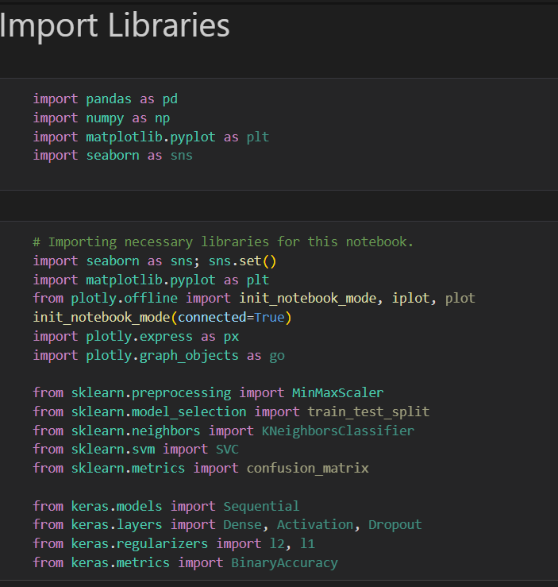

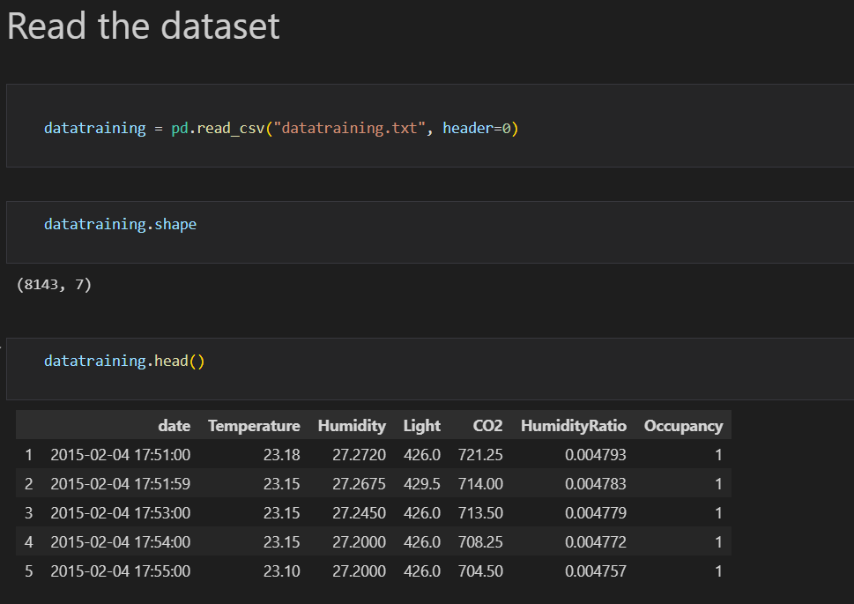

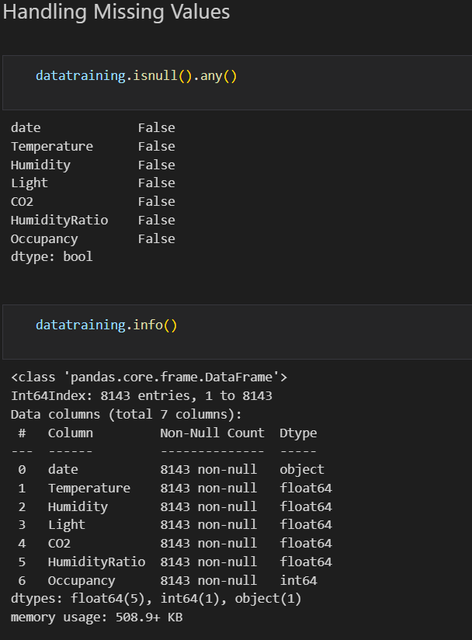

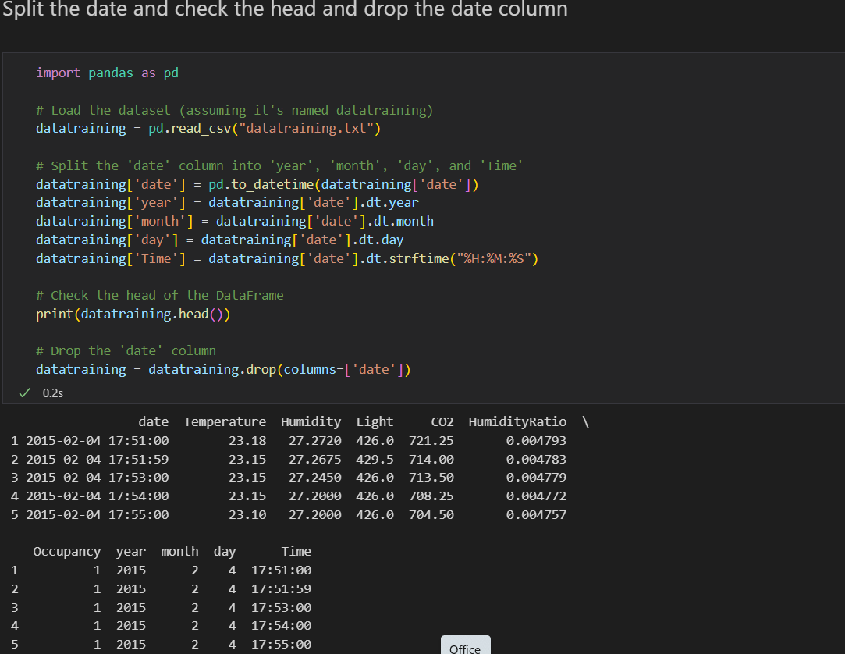

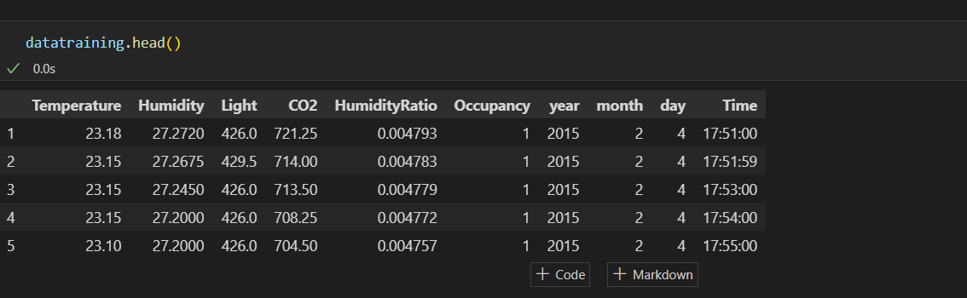

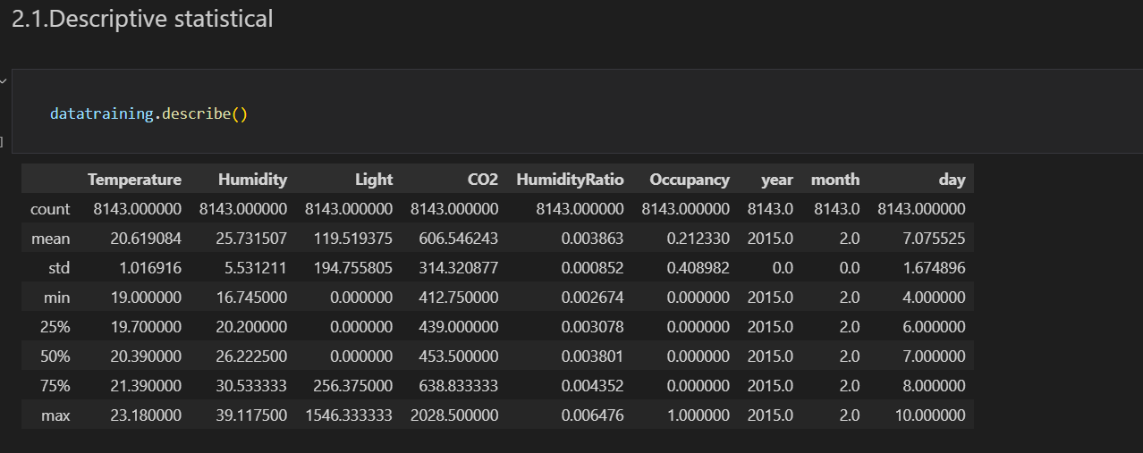

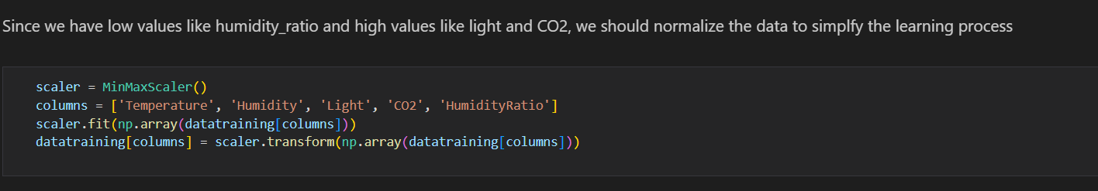

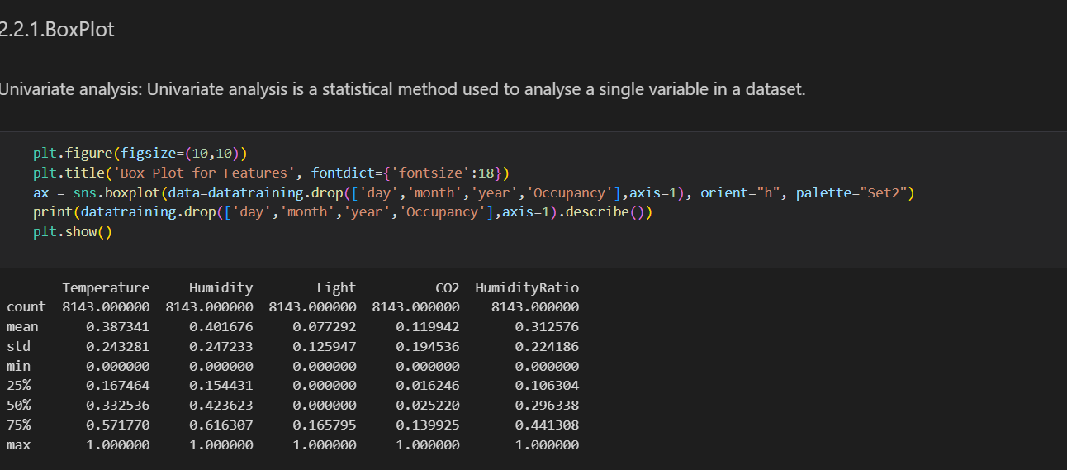

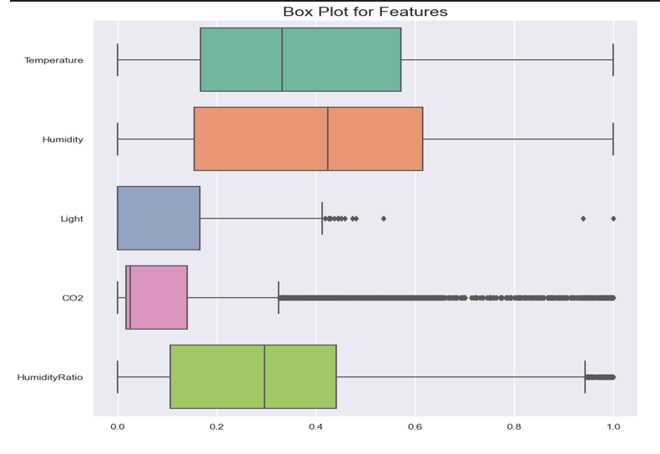

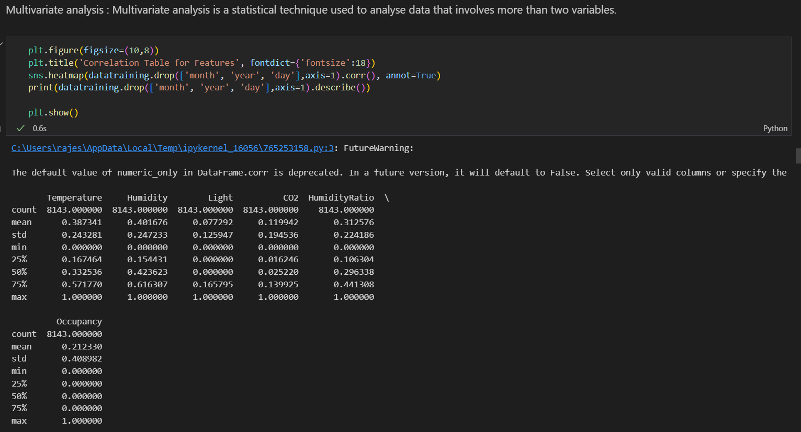

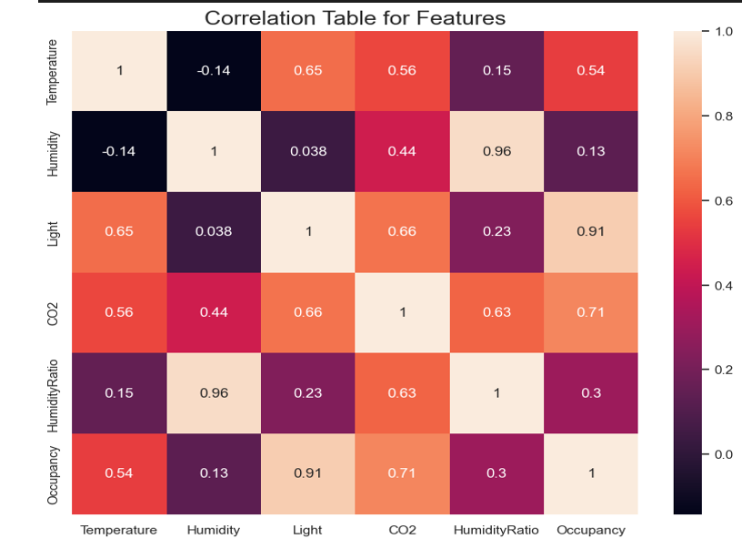

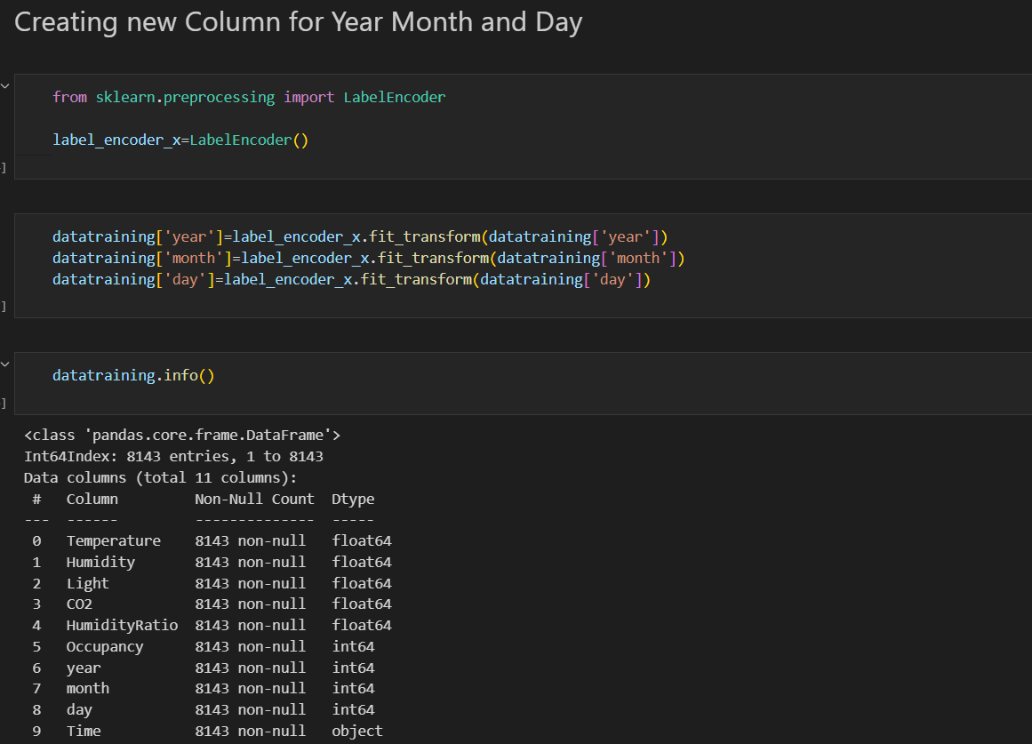

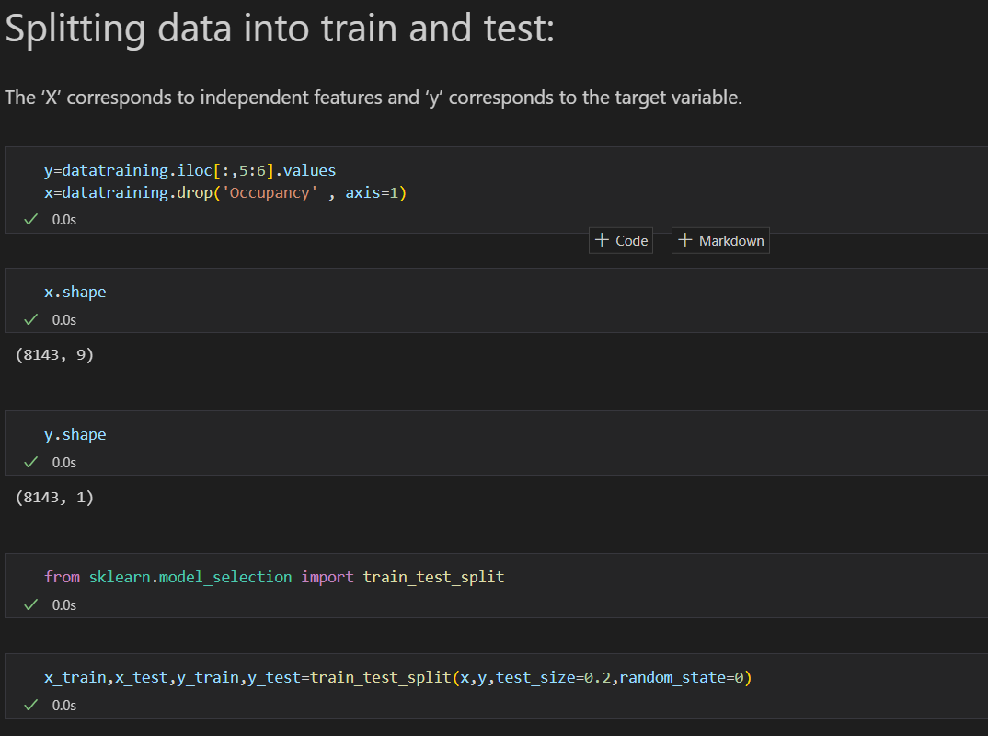

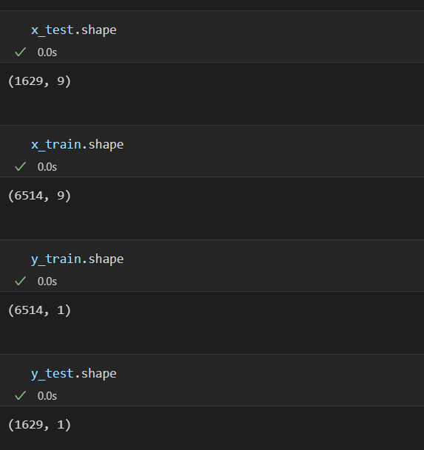

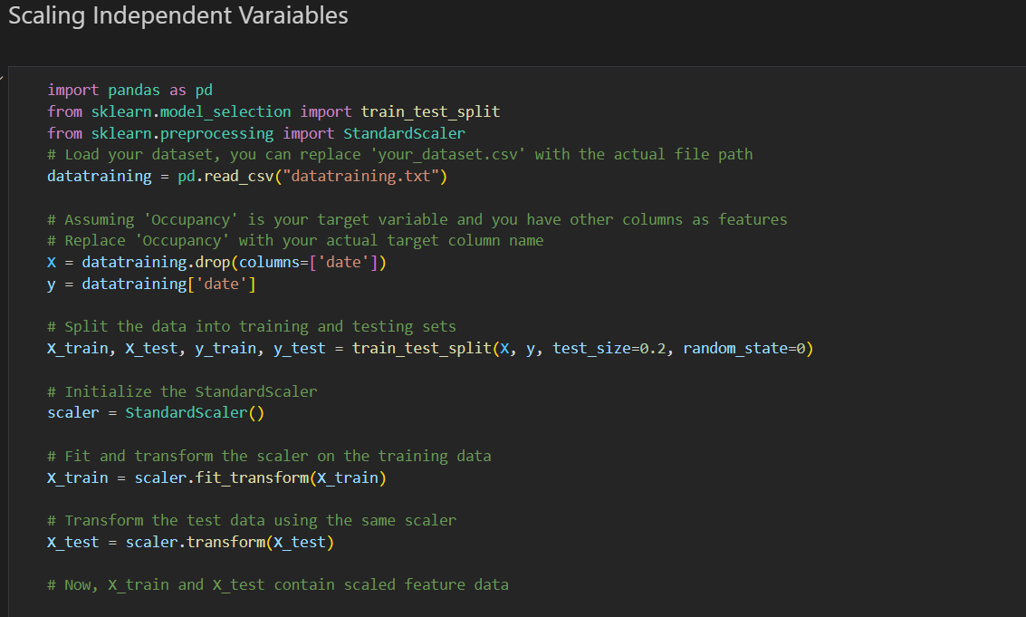

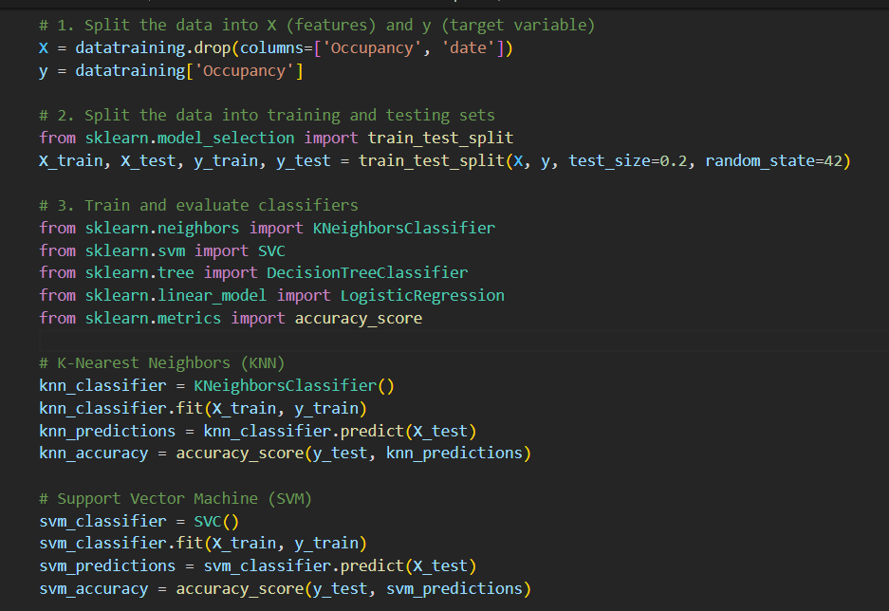

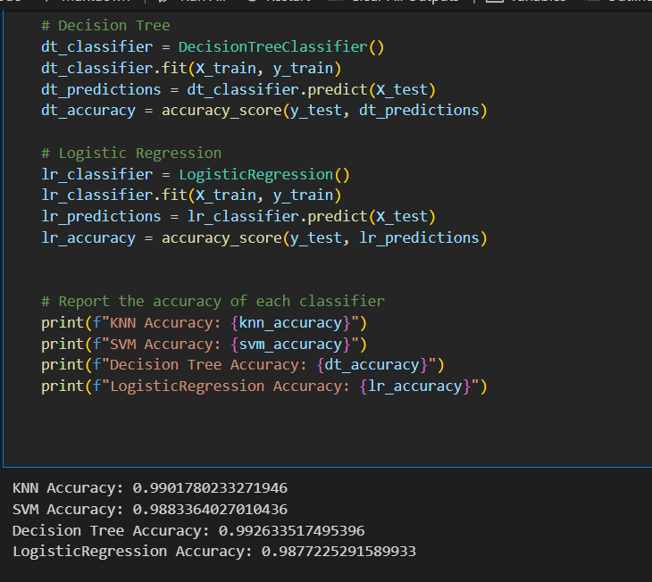

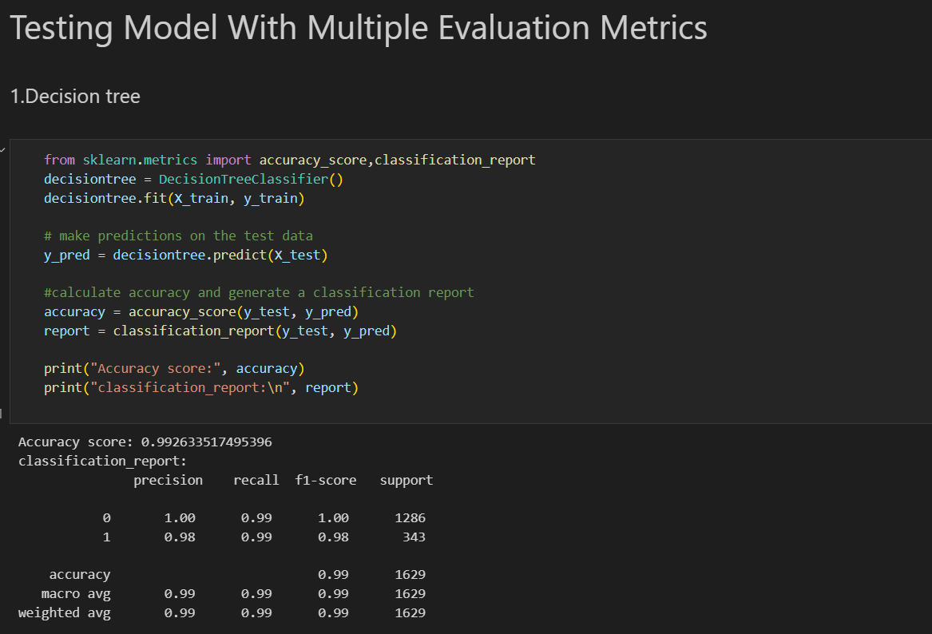

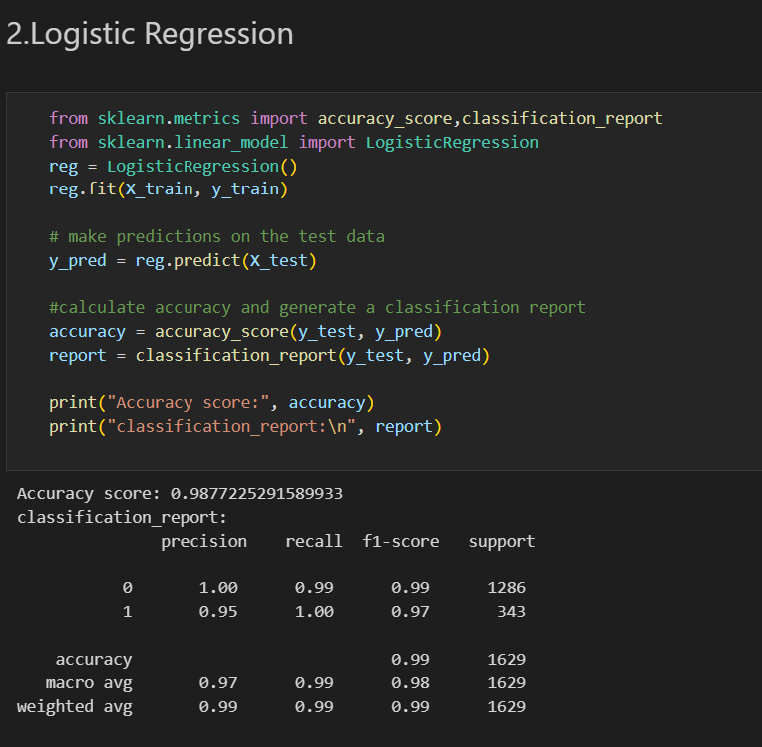

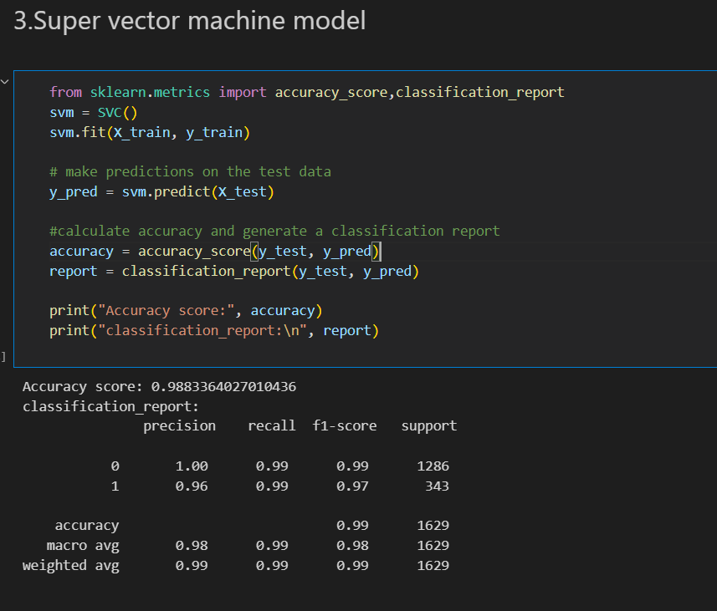

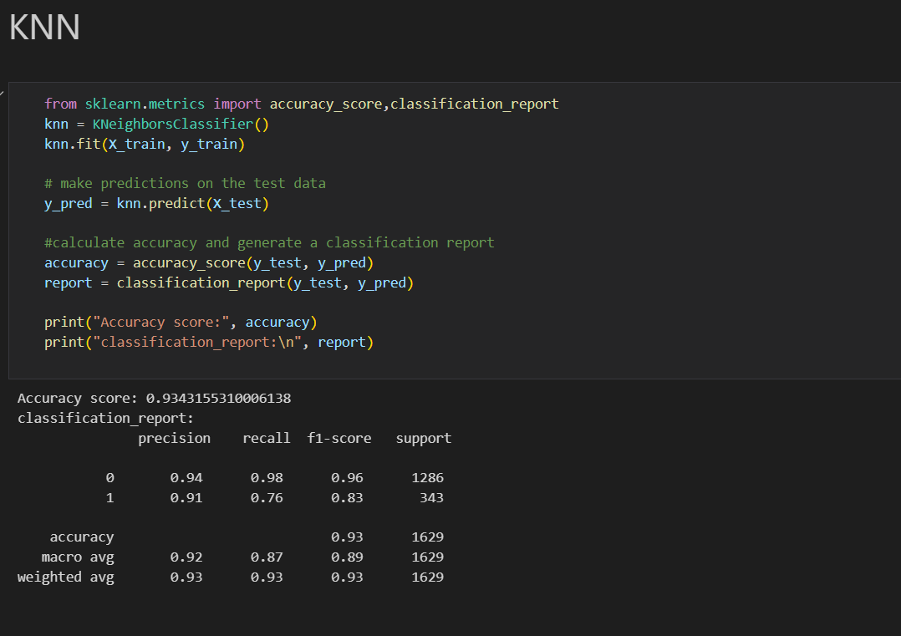

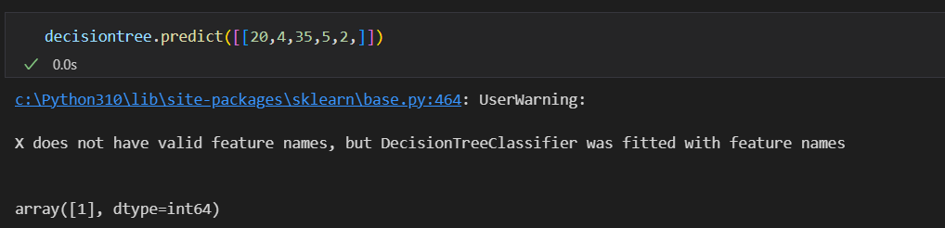

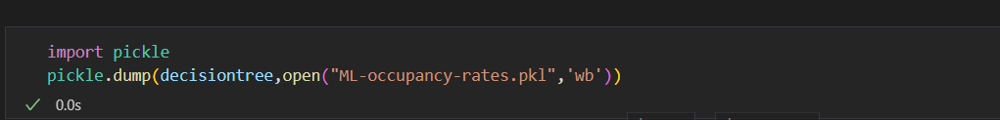

THANK YOU!...